List out all available cars from all warehouse
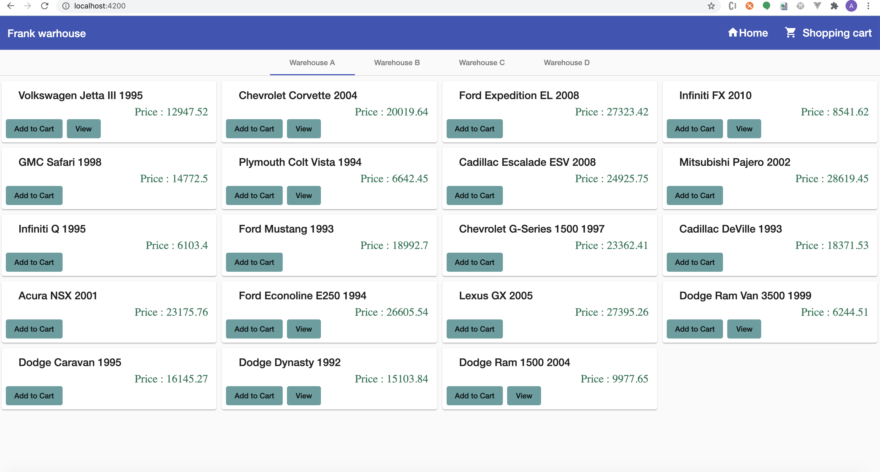

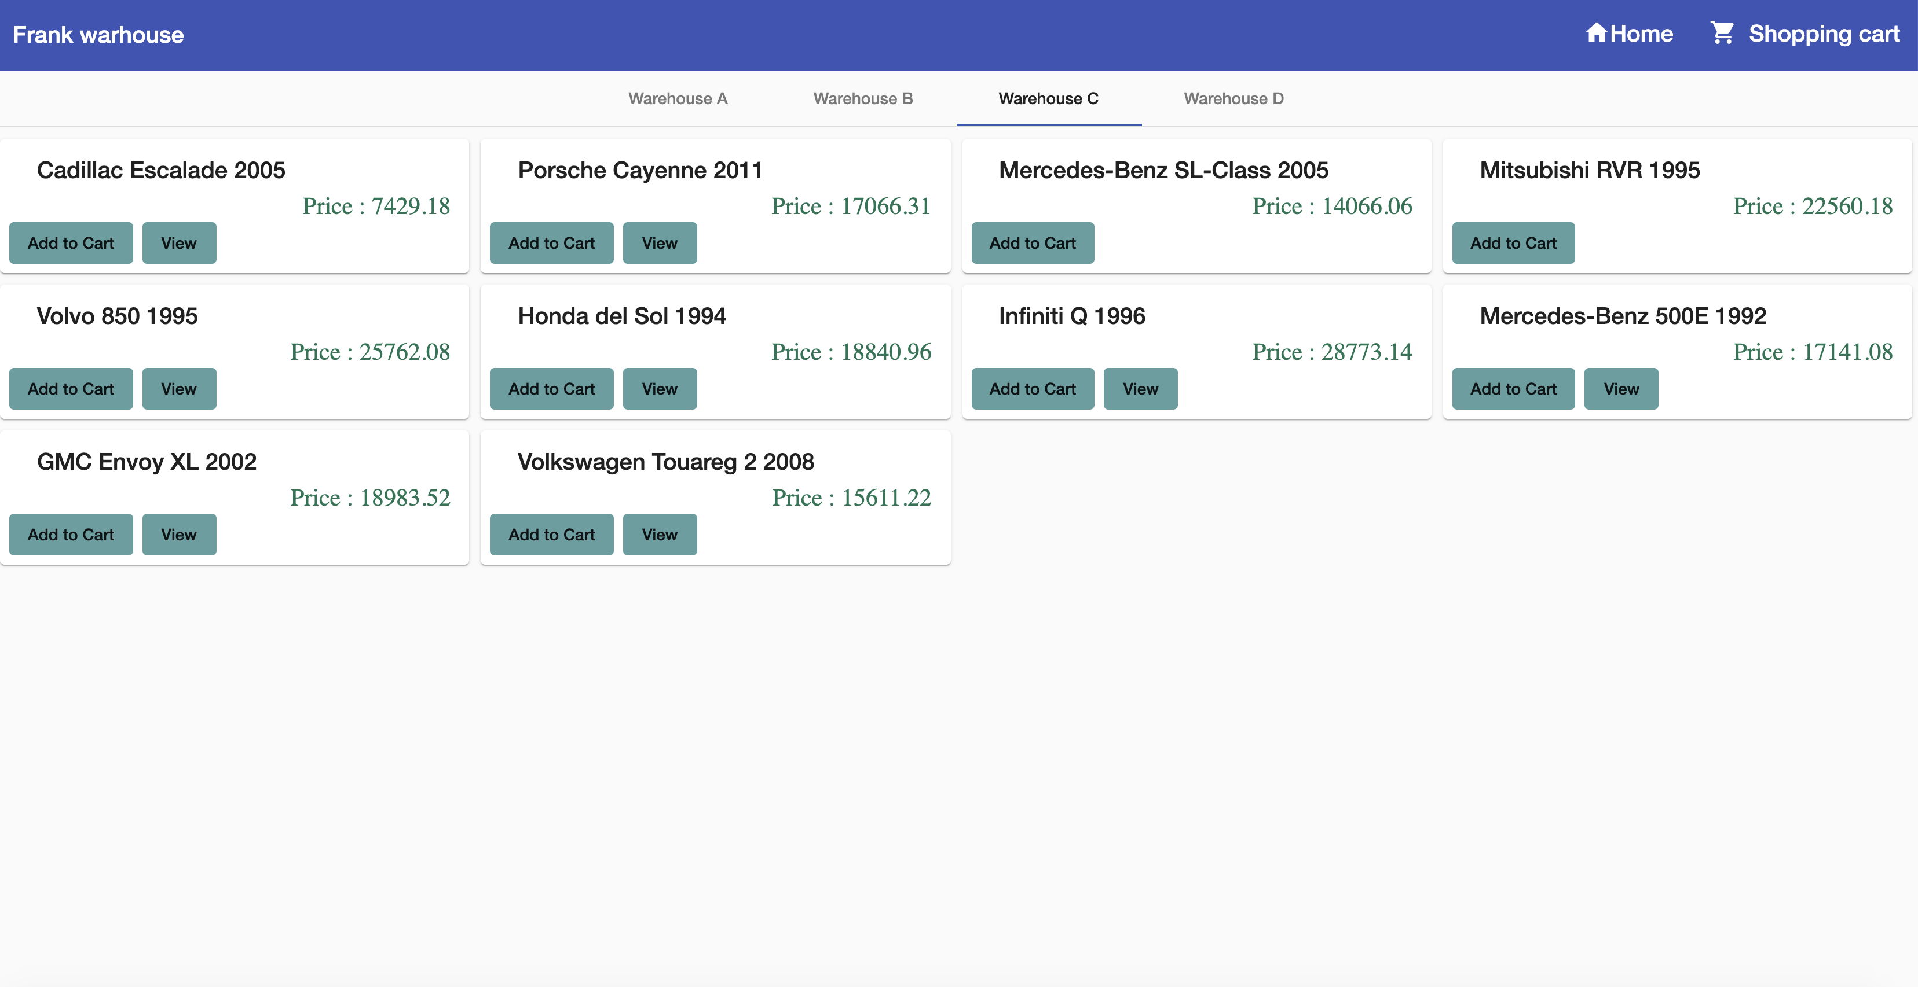
Filtered the cars based on the warehouse.It will be more user friendly and will give good look.

The cars have licensed = true have option to view and see more information

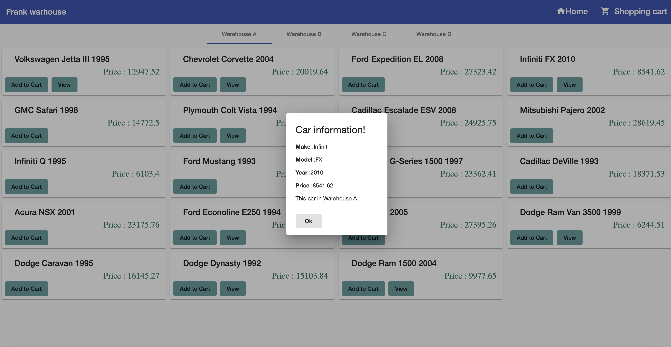

Once the user added the cars to cart.The list of selected car and detail will be in shopping cart page.

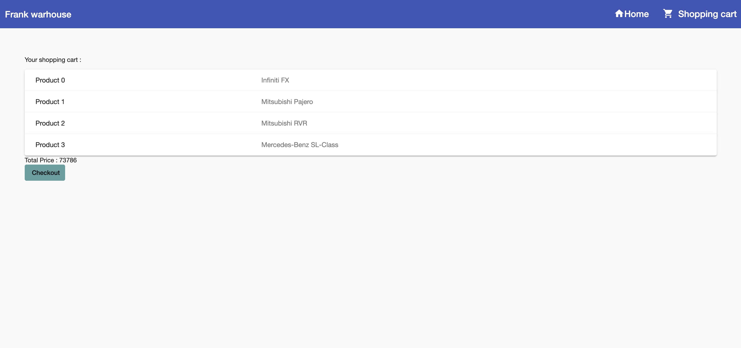

Here also user have option to click any product and see the details.
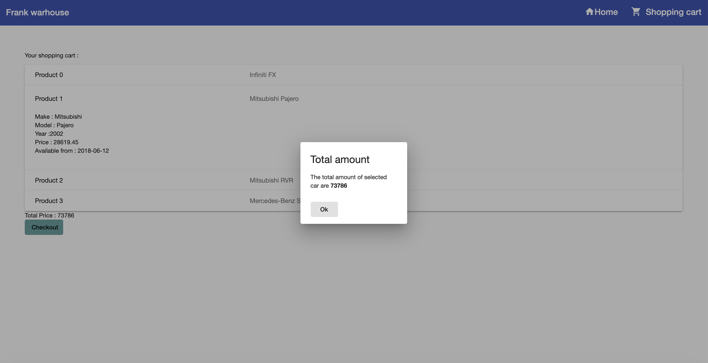

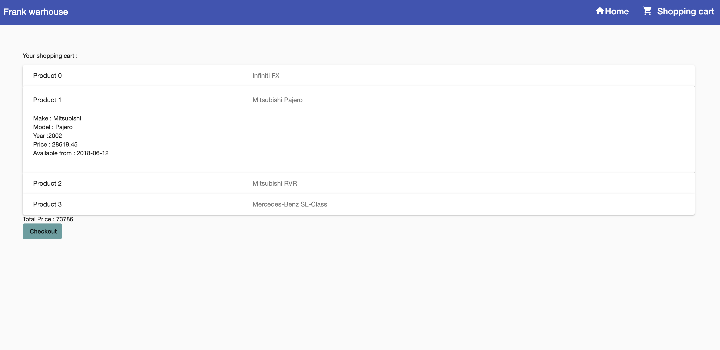
When user click the checkout button the dialog box with total cost of selected cars will be displayed

